Service Discovery / Service Registry with Eureka - Complete Notes

Introduction
We've already built three microservices:
- User Service (port 8081, MySQL)
- Hotel Service (port 8082, PostgreSQL)
- Rating Service (port 8083, MongoDB)
This video implements Service Discovery (also called Service Registry) — a crucial infrastructure component for microservices.
Note: If you haven't seen the previous videos, links are in the description box.

What Is Service Discovery / Service Registry?
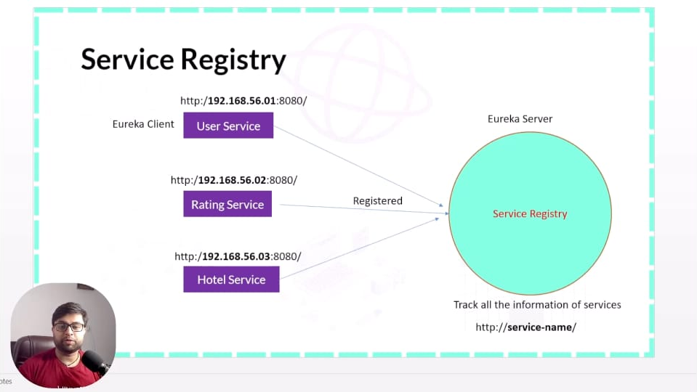

Purpose
- Create a Service Registry (Service Discovery Server) where all other services register themselves
- Enables load balancing across services
- Eliminates the need to hardcode IP addresses and ports of individual services
- Automatically tracks UP/DOWN status of each service

Benefits
Benefit | Description
Load balancing | Distributes requests across multiple instances
Service discovery by name | Call services by name instead of IP
Status tracking | Know which services are UP/DOWN
No hardcoded IPs | IP/port changes handled transparently
Centralized registration | All services visible in one place

What It Shows
The dashboard displays:
- Which services are registered
- Which are running (UP) or down (DOWN)
- Service names
- Additional metadata (host, port, instance ID)

Implementation: Eureka Server
We'll use Netflix Eureka — the most common service registry implementation. Spring Cloud provides excellent integration via spring-cloud-starter-netflix-eureka-server.
Important: The service registry server is also a Spring Boot project — it's a microservice itself.

Step 1: Create the Service Registry Project

Via Spring Initializr
Setting | Value
Project Type | Maven
Language | Java
Spring Boot Version | 2.7.5 (stable)
Group | com.lcd (or your preference)
Artifact | service-registry
Name | service-registry
Package | com.service (or com.lcd.service)

Dependencies
Two critical dependencies:
Dependency | Purpose
Spring Cloud Bootstrap (spring-cloud-starter-bootstrap) | Provides non-specific Spring Cloud features
Eureka Server (spring-cloud-starter-netflix-eureka-server) | Provides Eureka Server implementation
Note:
- Eureka is Netflix's open-source project
- Spring Boot provides excellent integration — makes using it very easy
- Spring Cloud Starter lets us use Spring Cloud features
- Spring Cloud Starter Netflix Eureka Server is specifically for creating the discovery server

Generate and Extract
- Click Generate — downloads ZIP
- Extract the ZIP
- Delete the ZIP after extraction
- Open in IntelliJ via Maven → + → Add Maven Project — select parent directory (with pom.xml)

Step 2: Verify Dependencies in pom.xml
Open pom.xml and verify the two important dependencies are present:
xml
<dependency>
<groupId>org.springframework.cloud</groupId>
<artifactId>spring-cloud-starter-netflix-eureka-server</artifactId>
</dependency>

<dependency>
<groupId>org.springframework.cloud</groupId>
<artifactId>spring-cloud-starter-bootstrap</artifactId>
</dependency>

Also Important: Spring Cloud Dependency Management
There should be a dependencyManagement section with:
xml
<dependencyManagement>
<dependencies>
<dependency>
<groupId>org.springframework.cloud</groupId>
<artifactId>spring-cloud-dependencies</artifactId>
<version>2021.0.5</version> <!-- version varies -->
<type>pom</type>
<scope>import</scope>
</dependency>
</dependencies>
</dependencyManagement>
Critical: If this <dependencyManagement> block (specifically the Spring Cloud dependency tag) is missing, Spring Cloud dependencies will not work. This is generated automatically by Spring Initializr when you select Spring Cloud dependencies.

Step 3: Enable Eureka Server

Main Application Class
java
@SpringBootApplication
@EnableEurekaServer
public class ServiceRegistryApplication {
public static void main(String[] args) {
SpringApplication.run(ServiceRegistryApplication.class, args);
}
}

Key Annotation
- @EnableEurekaServer — Marks this project as a Eureka Server (discovery server / service registry)
- Without this, the project is just a regular Spring Boot app — not a registry

Step 4: Configure application.yml

Create the Configuration File
In src/main/resources, create application.yml:
yaml
server:
port: 8761

eureka:
instance:
hostname: localhost
client:
register-with-eureka: false
fetch-registry: false

Configuration Breakdown

Server Port
- Default port for Eureka Server: 8761
- Can keep the default or change it (some use 8080, 8081, etc. — but 8761 is the standard)
- We keep 8761 here

Eureka Instance Config
Property | Value | Purpose
eureka.instance.hostname | localhost | Hostname of the registry server

Eureka Client Config — CRITICAL
Property | Value | Why
eureka.client.register-with-eureka | false | The registry server should NOT register itself as a client
eureka.client.fetch-registry | false | The registry server should NOT fetch its own registry (it IS the registry)

Why These Two Flags Are Set to false
Default behavior: Both are true. The registry would try to register itself and fetch its own registry — which is nonsensical.
- register-with-eureka: false → Prevents the server from registering itself as a client
- fetch-registry: false → Prevents the server from fetching registry information from itself
Think of it this way: The registry is like a phonebook. It doesn't need to look itself up in its own pages. The other services (clients) do the registering and fetching.

Without These Flags Set to false
- The registry would attempt to register itself → cycle of self-registration
- It would try to fetch from itself → unnecessary work
- Log errors appear on startup — but function may still work; still, always set these flags correctly

Step 5: Run the Eureka Server
Run ServiceRegistryApplication.java:
- Application starts on port 8761
- Console shows Eureka Server startup logs

Access the Eureka Dashboard
Open browser: http://localhost:8761
What you'll see initially:
- Eureka Server dashboard
- "No instances available" — because no services are registered yet
- Section labeled "Instances currently registered with Eureka" — currently empty

Dashboard Sections
Section | Purpose
System Status | Overall UP/DOWN status of the server
DS Replicas | Replicas of the registry (for HA setups)
Instances currently registered with Eureka | List of all registered services (with UP/DOWN status)
General Info | Environment, version, host details
Instance Info | This server's own instance metadata

Step 6: About the spring-boot-starter-web Dependency

The Tutorial's Note
The instructor added spring-boot-starter-web initially to test something, then removed it — because the Eureka Server project doesn't need web endpoints.

Why Web Dependency Was Removed
- The Eureka Server already serves its own dashboard (via its internal web server)
- We don't write any @RestController endpoints in this project
- The Eureka starter brings its own embedded web server
- Adding spring-boot-starter-web is redundant — no harm but no benefit

What Happens Without It
- The Eureka Server still works fine
- The dashboard is still accessible on 8761
- This confirms the removal is safe
Lesson: You can add/remove dependencies as needed — no harm in adjusting. Only add what you actually use.

Dashboard After Registration (What Will Happen Next)
Once we register the other services (User, Hotel, Rating) as Eureka clients, the dashboard will show:
- "Application" column: USER-SERVICE, HOTEL-SERVICE, RATING-SERVICE
- "Status" column: UP (1) — count of instances
- Clickable links — clicking takes you to that service's info
- Additional metadata: Host, port, instance ID, last heartbeat, etc.
Multiple instances: If a service runs multiple instances, the dashboard shows all, and Eureka handles load balancing.

Architecture Review

Registration Flow
text
┌──────────────────┐
│ Eureka Server │ (Service Registry)
│ Port: 8761 │
└────────┬─────────┘
▲
│ registers (client mode)
│
┌────┴────┬─────────────┐
│ │ │
User Svc Hotel Svc Rating Svc
(8081) (8082) (8083)

How Services Use It
- Each service starts up with Eureka client dependency
- On startup, registers itself with Eureka Server (provides name, host, port)
- Sends heartbeats every ~30 seconds to confirm it's alive
- If no heartbeat for ~90 seconds → Eureka marks the service DOWN
- Other services query Eureka to find service addresses
- Eureka distributes requests across multiple instances (load balancing)

Step 7: What's Needed for Client Services (Next Video)
The current Eureka Server is empty. To populate it, the other three services (User, Hotel, Rating) need to become Eureka clients.

Required Steps for Each Client Service
- Add Eureka Client dependency:
xml
<dependency>
<groupId>org.springframework.cloud</groupId>
<artifactId>spring-cloud-starter-netflix-eureka-client</artifactId>
</dependency>
- Add @EnableEurekaClient annotation (or rely on auto-config)
- Add configuration in application.yml:
yaml
eureka:
client:
service-url:
defaultZone: http://localhost:8761/eureka/
- Ensure spring-cloud-dependencies in dependencyManagement (same as server)
Next video will demonstrate this — making all three services clients so they register with this registry.

Key Configuration Summary

application.yml (Service Registry)
yaml
server:
port: 8761

eureka:
instance:
hostname: localhost
client:
register-with-eureka: false
fetch-registry: false

Why Each Line Matters
Config | If Missing/Wrong
@EnableEurekaServer | Project won't function as a registry
register-with-eureka: false | Server tries to register itself — creates logs/loops
fetch-registry: false | Server tries to fetch its own registry — unnecessary
server.port: 8761 | Doesn't matter (any port works) — but 8761 is convention
Spring Cloud dependencyManagement in pom.xml | Cloud deps won't resolve — build fails

Important Warnings from the Instructor
- Careful with configuration — a small mistake can break the registry
- Follow step-by-step — don't skip
- Compatible versions matter — Spring Boot 2.7.5 + Spring Cloud 2021.x is a good combo
- Minimum configuration shown — in real projects, adjust as per company's requirements

Testing / Verification Steps

Step 1: Start the Eureka Server
bash
mvn spring-boot:run

Step 2: Open browser
text
http://localhost:8761

Step 3: Verify
- Dashboard loads successfully
- "Instances currently registered with Eureka" = empty (no clients yet)
- System status = UP

Step 4: Stop the Server (when done testing)
- Confirms application starts/stops cleanly

Common Issues and Fixes
Issue | Cause | Fix
404 on / | Missing Eureka Server dependency | Add spring-cloud-starter-netflix-eureka-server
Registry shows error about self-registration | register-with-eureka not set to false | Set it to false
Build fails: dependency unresolved | Spring Cloud dependencyManagement missing | Verify pom.xml has the Spring Cloud dependency tag
Dashboard loads but nothing registers | Services aren't clients yet | Next video — add Eureka client to each service
Port conflict | Another app using 8761 | Change server.port (but keep it consistent across clients' defaultZone)

Files Created in This Video
File | Purpose
ServiceRegistryApplication.java | Main class with @EnableEurekaServer
application.yml | Eureka Server config (port, hostname, client flags)
That's it — the Eureka Server is a very simple project. The complexity is in the config, not the code.

Key Takeaways
- Service Registry = Service Discovery Server — centralized phonebook for microservices
- Use Eureka — Netflix's service discovery implementation, easily integrated via Spring Cloud
- Port 8761 — the default Eureka Server port (keep it as standard)
- @EnableEurekaServer — one annotation activates the server
- Two critical flags in config:
  - eureka.client.register-with-eureka: false — don't self-register
  - eureka.client.fetch-registry: false — don't fetch own registry
- Dashboard at http://localhost:8761 — shows all registered services
- Currently empty — no clients registered yet
- Next step: register User, Hotel, Rating services as Eureka clients
- Spring Cloud dependencyManagement — essential in pom.xml
- Removed spring-boot-starter-web — not needed for the registry itself

What Comes Next
The next video will:
- Add Eureka Client dependency to each service (User, Hotel, Rating)
- Configure defaultZone: http://localhost:8761/eureka/ in each service's application.yml
- Start the three services → they register automatically
- Verify all three appear in the Eureka dashboard
- Then use service names (instead of IP addresses) for inter-service communication

The Bigger Picture

Why Service Registry Is Critical
Without Service Registry:
- Hardcoded http://localhost:8082/hotels/... for Hotel calls
- Hardcoded http://localhost:8083/ratings/... for Rating calls
- If any service changes port/host → all callers must update code
- No automatic load balancing
With Service Registry:
- Call by service name: http://hotel-service/hotels/...
- Load balancing handled automatically
- IP/port changes transparent to callers
- Centralized visibility into microservice topology

Alignment with Microservice Principles
- Loose coupling — services don't need to know each other's physical addresses
- Scalability — register more instances; load balancer distributes
- Resilience — DOWN services detected and removed from rotation
- Discoverability — new services just register and become available

Quick Reference
Item | Value
Server Port | 8761 (default)
Dashboard URL | http://localhost:8761
Eureka Server dependency | spring-cloud-starter-netflix-eureka-server
Spring Cloud Bootstrap dependency | spring-cloud-starter-bootstrap
Main annotation | @EnableEurekaServer
Client register flag | eureka.client.register-with-eureka: false
Client fetch flag | eureka.client.fetch-registry: false
Client defaultZone (for clients) | http://localhost:8761/eureka/

Summary
This video implemented the Service Registry using Netflix Eureka:
- Created a dedicated Spring Boot project for the registry
- Added Eureka Server + Spring Cloud Bootstrap dependencies
- Enabled server via @EnableEurekaServer
- Configured port 8761, hostname localhost
- Set self-registration and self-fetching to false
- Verified: server runs, dashboard loads at localhost:8761, currently empty
Next: Register the three microservices (User, Hotel, Rating) with this registry, then use service names for inter-service communication and load balancing.

